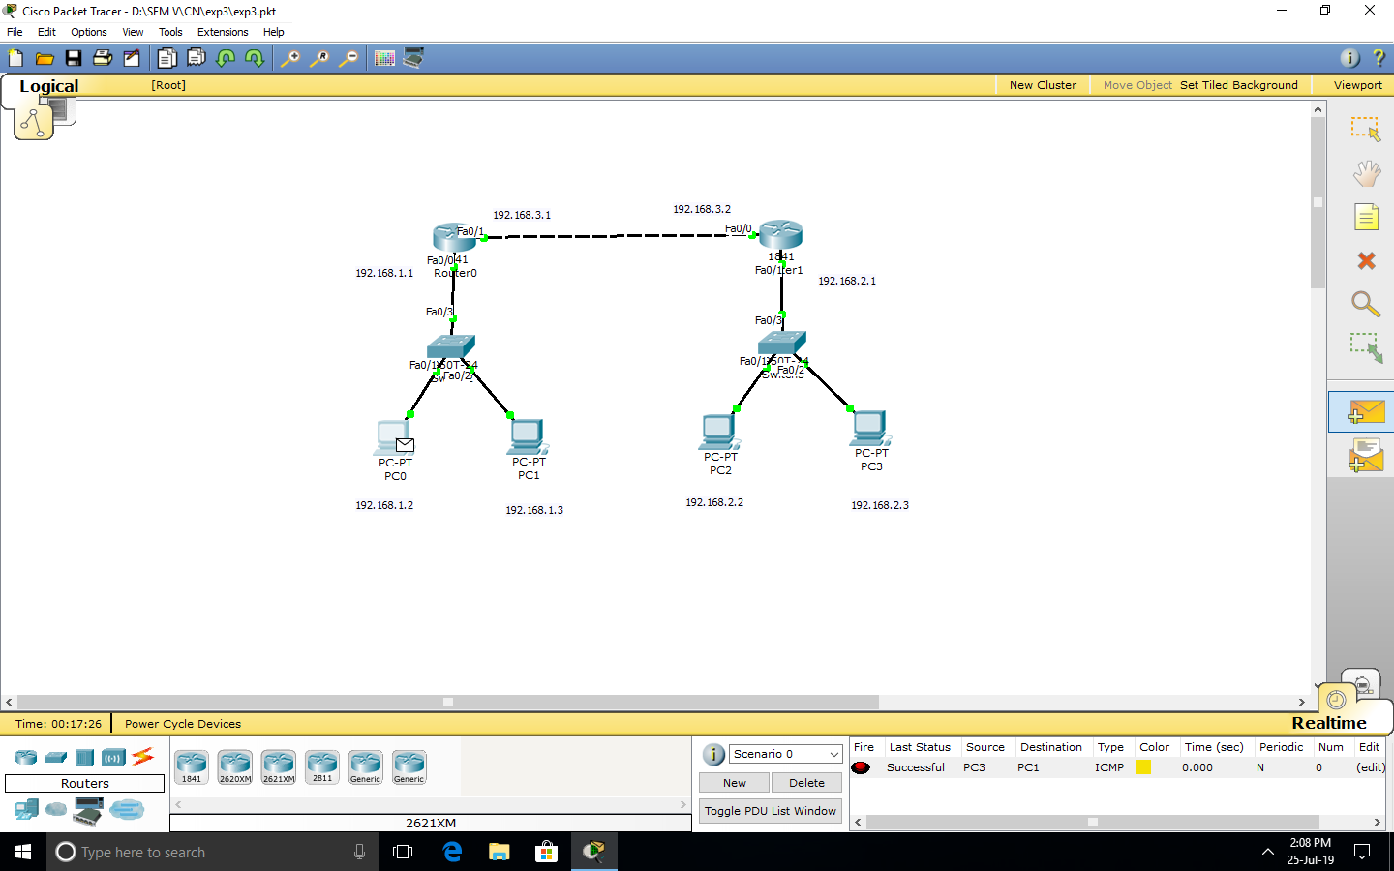

**FIGURE 1: SENDING MESSAGE FROM PC0 TO PC2**

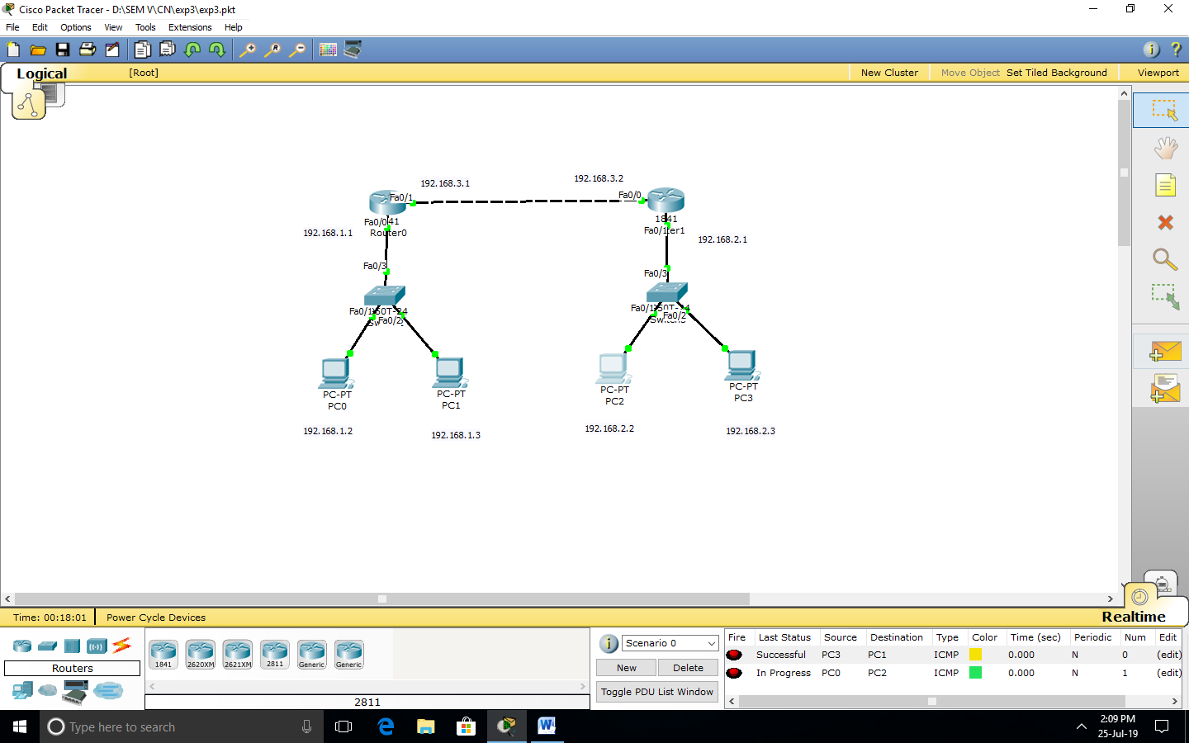

**FIGURE 2: MESSAGE SENT FROM PC0 TO PC2**

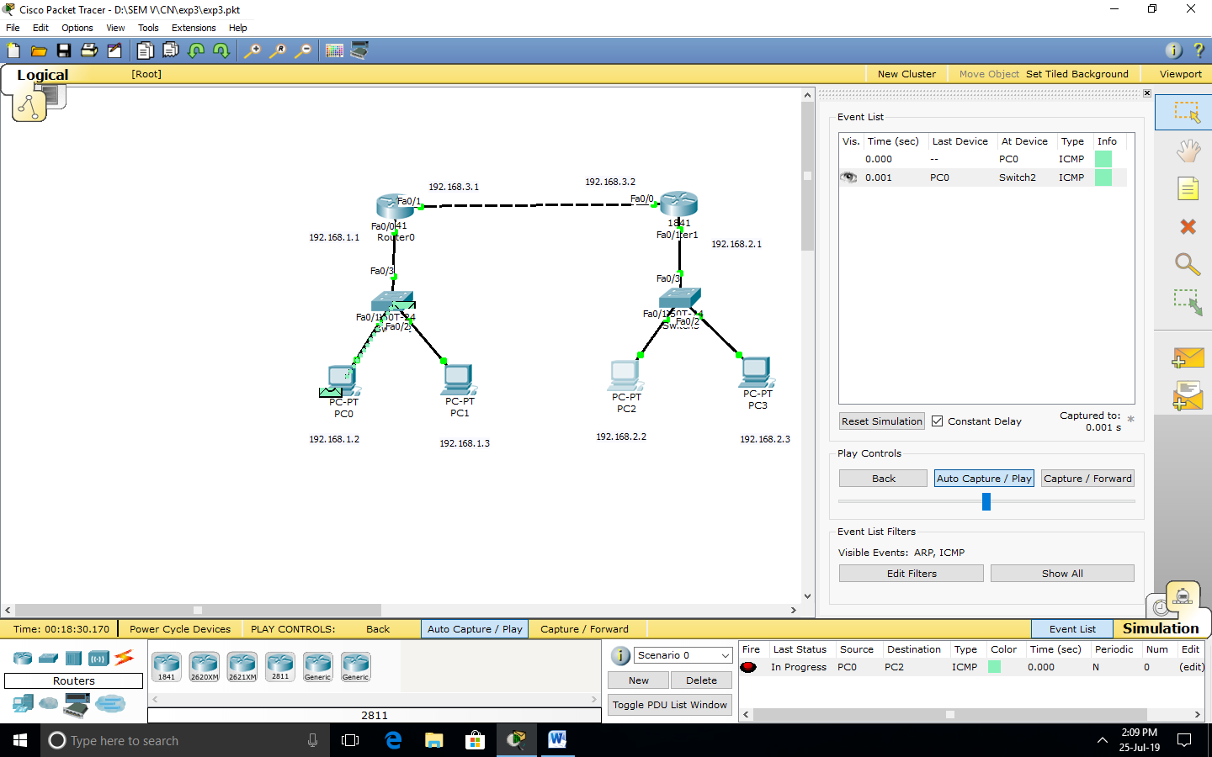

**FIGURE 3: MESSAGE SENT FROM PC0 TO SWITCH0**

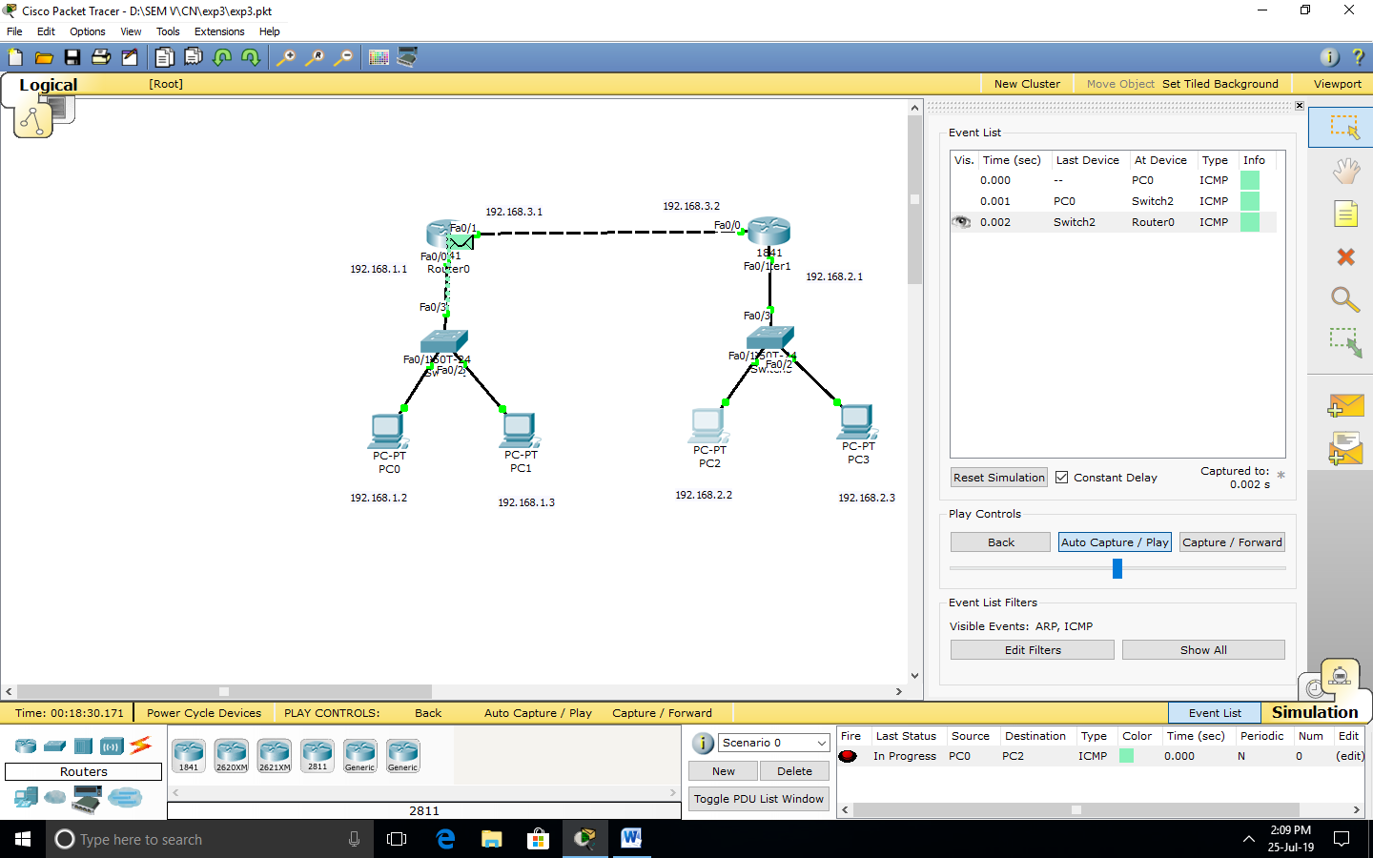

**FIGURE 4: MESSAGE SENT FROM SWITCH0 TO ROUTER 0**

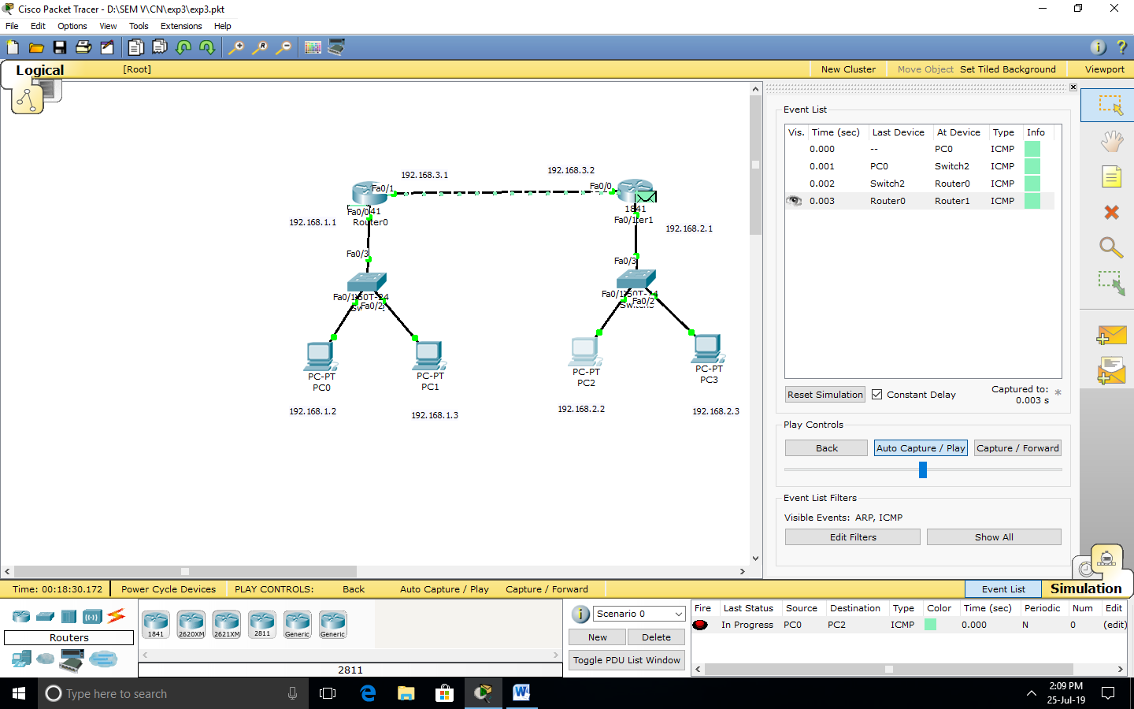

**FIGURE 5: MESSAGE SENT FROM ROUTER0 TO ROUTER1**

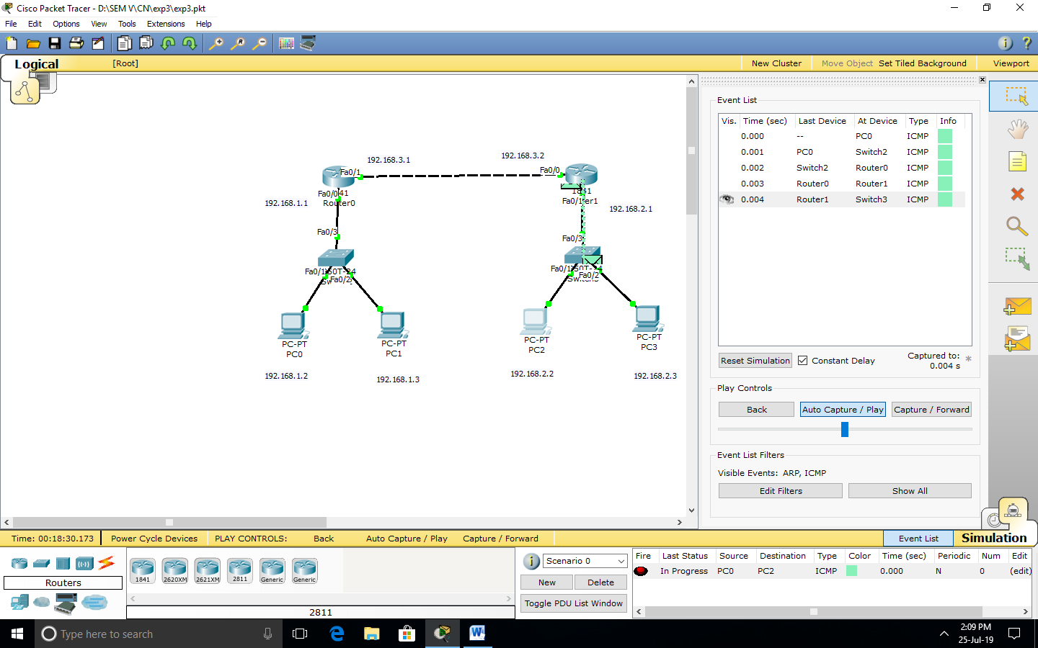

**FIGURE 6: MESSAGE SENT FROM ROUTER1TO SWITCH1**

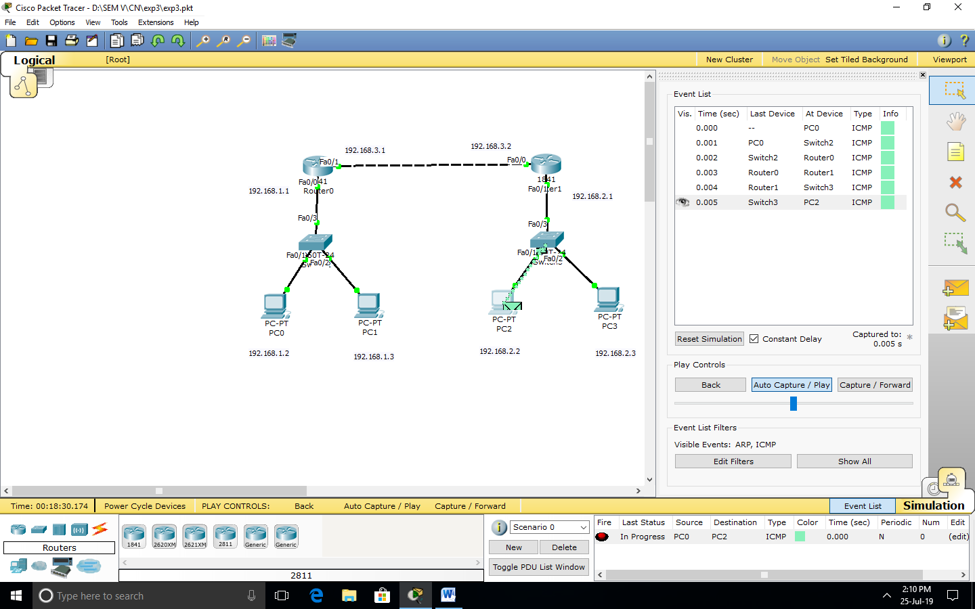

**FIGURE 7: MESSAGE SENT FROM SWITCH1 TO PC2**

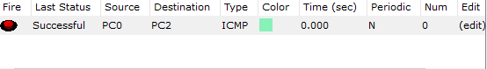

**FIGURE 8: MESSAGE SENT FROM PC0 TO PC2 SUCCESSFULLY**

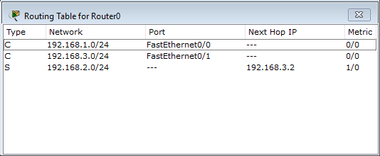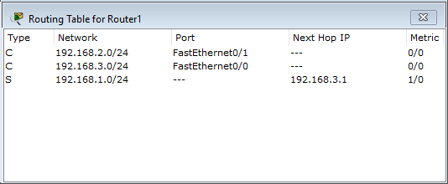

**FIGURE 9: ROUTING TABLE OF ROUTER0 AND ROUTER1**